# Permit fees - Advanced Reservation Options

When working with the Advanced Reservation Settings for a facility fee you can select very specific requirements for each fee needed to be associated to any reservation. These options are under the Advanced Reservation Options.

You will need to check the box to **Activate (and show) Advanced Options.** 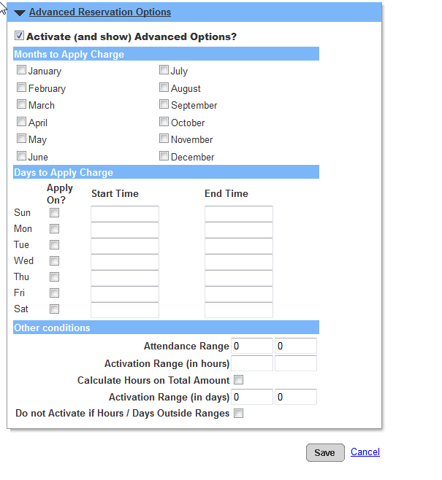

## You have the option to regulate the months of the year that you would like the fee to apply.

This is helpful if you have different seasons that the facility will be booked for. You can create a different fee for each grouping of months that are linked to a specific season.

Some sites have pricing policies for specific months

e.x. BCIT Locker reservations have different prices for different months

## You can select specific days of the week that a fee will be linked to the reservation.

If the weekday fee is different for the weekend fee you would create a weekday fee and include the days of the week needed. Then create a second fee for the weekend rate and again link the days of week needed.

e.x. If a site wants to charge more for rentals that occur on a weekend

## You can also use this option to create Prime time and Non-prime time fees for a facility.

You would designate a day of the week and a time frame for the Prime time fee and then create a second fee for the Non-prime time and link the days of the week and the time frame for this fee.

e.x. Some sites have Baseball fields with lighting and will charge different fees for the times when the field is lit and unlit.

## There are other conditions that you can link to any fee.

You can use an attendance range for the fee. This can regulate a group size for a specific fee.

e.x. Have a party and there are resources (supervisor or food or security) available for specific amount of people

You can link a range of hours for a specific fee.

For instance, if the reservation is for 1-3 hours a certain fee will prompt. If the reservation is more than 3 hours you can have a different fee prompt.

You can calculate the amount for the total numbers of hours linked to a permit instead of each reservation linked to the permit.

You can link a fee to a specific amount of days linked to a permit. This allows you to give a different fee amount for a specific range of days booked on a permit.

e.x. A rental that starts on Saturday afternoon and ends at 11:59PM is charged a different fee if it ends on Sunday morning at 8AM.

Lastly you have the option to prevent a fee from activating unless it falls within the given range built out in the previous option.

# Considerations

If activation ranges are selected (for hours, attendance or days) for the charge, then they appear on the permit as add on charges separate from the base permit charge.

Generally, for charges, if you change anything at the charge level, it does not apply to the version of it already attached to the facility charge matrix. However, if you change something at the advanced reservation option section, it will update the charge right away.